King Fahd University of Petroleum and Minerals
Information and Computer Science Department

ICS 103: Computer Programming in C
Spring Semester 2007-2008 (Term-072)

Final Exam

Time:120 minutes Wednesday June 11, 2008

Name:
ID#:

PLEASE CIRCLE YOUR SECTION BELOW:

Section | 01 | 02 | 03 | 04 | 05 | 06
Time | SM-8-9 | SM 9-10 | SM 11-12 | UT 9-10 | UT 11:12 | UT 10-11

Note:

- Copying or Discussion will result in zero grade for all the students involved.
- Attempt all questions.

Question # | Maximum Marks | Obtained Marks
P1,P2,P3 | 7+6+7=20
P4,P5,P6 | 10+9+6=25
2 | 15
3 | 20
4 | 20
Total | 100

Good Luck

Question 1: (45 points)
Find the output of the following programs.
Program | Output
#include <stdio.h> // 7 pts
int main() {
int i,j;
i=5;
while (i>2) {
j=3;
do {
printf("%d\t",i+j);
j=j+i;
} while(j<13);
printf("\n");
i=i-2;
}
printf("%d",i);
return 0;
}

#include <stdio.h> // 6 points
void fun(int a, int *b) {
if(a> *b) {
*b=*b+1;
a=a-1; }
else {
*b=*b-1;
a=a+1;
}}
int main() {
int i;
int a[]={2,5,8,4,36,22,25,45,11,16,20,19};
for(i=0;i<6;i=i+2) {
fun(a[i],&a[i+1]);
}
for(i=0;i<12;i=i+2)
printf("%d\t",a[i]);
return 0; }

#include <string.h> // 7 points
#include <stdio.h>
void wow (char s[],int i);
int main() {
char s[]="n512fab76ibmw8";
wow(s,strlen(s)-1);
return 0;
}
void wow (char s[],int i) {
if(i>=0){
printf("%c\n",s[i]);
wow(s,i-2);
}}

#include <stdio.h> // 10 points
int main() {
int a[6],b[3][3],i,j ;
for(j=0;j<3;j++){
for(i=0;i<3;i++)
scanf("%d",&b[i][j]);
}
for(j=1;j<=2;j++) {
for(i=0;i<=2;i=i+2)
printf("%d\t",b[i][j]);
}
printf("\n");
for(i=0;i<6;i++) {
a[i]=b[i%2][i%3];
printf("%d\t",a[i]);
}
return 0;}

input typed by the user:

7 9 14
11 2 5
3 6 8

#include <stdio.h> // 9 points
int main() {
int a[6],b[3],k,j=0;
printf("Enter 6 integer values >");
for(k=0;k<=5;k=k+2) {
scanf("%d%d",&a[k],&b[j]);
j++;
}
for(k=0;k<=2;k++) {
for (j=0;j<=4;j=j+2) {
if(b[k]>=a[j]) {
a[j+1]=b[k];
b[k]=a[j];
break;
}
}}
j=0;
for(k=1;k<=6;k=k+2) {
printf("%d\t%d\n",a[k],b[j]);
j++;
}
return 0;}
input typed by the user:

43 16 35 39 14 47

//abcdefghijklmnopqrstuvwxyz
#include <stdio.h> // 6 pts
#include <string.h>
int fun (char c1, char c2) {
return c1-c2;
}
int check(char t1[], char t2[]) {
return strlen(t1)-strlen(t2);
}
int main() {
int i;
char text[4][80]={"abcdef","dfeck","egn",
"bklmnwg"};
for(i=0;i<3;i++) {
printf("%d\t",check(text[i],
text[i+1]));
printf("%d\n",fun(text[i][0],
text[i+1][0]));
}
return 0;
}

Question 2 : (15 points)
Write a program that uses a loop to read 5 lines of text from a file “input.txt”. These lines will be stored in an array. Each line does not exceed 80 characters. After that, your program will find the line with smallest number of characters and prints it on the screen.
The following is an example showing a file with 5 lines and the output generated by the program. Your program output must be the same as the one shown below.

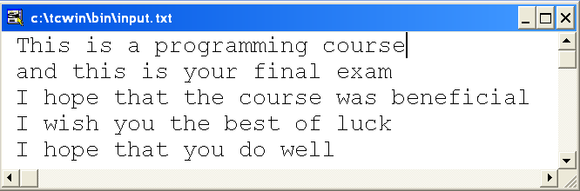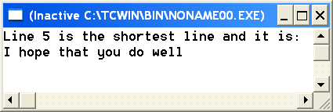

Question 3 : (20 points)
Write a program to multiply a matrix a (2-D array) by a vector b(1-D array) to obtain a vector c (1-D array). For this, declare a as a 2-D array with 10 rows and 10 columns and the 1-D arrays b and c with size 10. The value 10 must be defined as a constant. Your program will read the actual number of rows and columns from the user, then it will read the values of matrix a followed by the values of vector b. The number of columns of matrix a must be the same as number of values of vector b.
After finding vector c, your program will print its values.
$$c\left(i\right)=\sum_{j}{a\left(i,j\right)×b\left(j\right)}$$
An example of execution of your program is shown below. Your program output format must be the same as the one shown below.
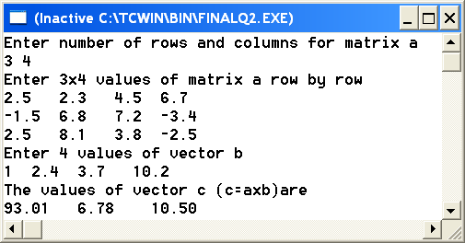

Question 4 : (20 points)
Write a program to separate the letters and digits present in a string. Your program contains the main function and a function sepletdig.
The function sepletdig will receive 3 1-D arrays of type char. One is the input containing the original string, the two others are output strings one of them containing digits and the other containing letters. Your function should go over the characters of the original string one by one. If the character is a letter, it will assign it to the array of letters. If it is a digit it will assign it to the array of digits. Your function does not return the count of letters or digits just the 2 strings.
No printing inside the function. Your program must execute as shown below. The second line represents the string typed by the user.
